 | 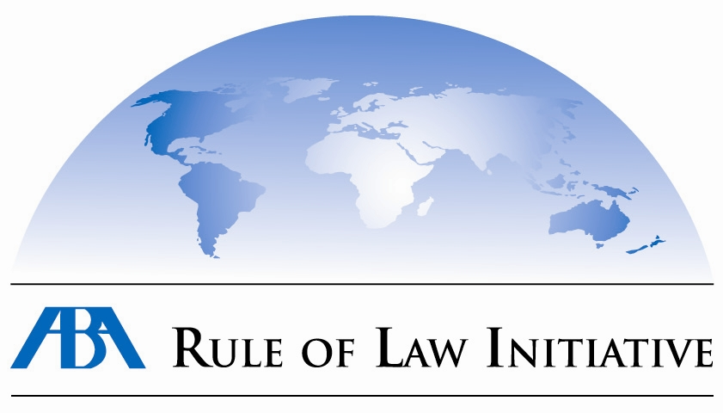

Public Monitoring of Court Hearings Concerning Human Trafficking Cases
Grant Competition

ABA Rule of Law Initiative (ABA/ROLI) with financial support from the US Department of State, INL Division announces a competition to get grants to participate in public monitoring of court hearings concerning human trafficking cases (art. 149 of the Criminal Code of Ukraine).

Goal of the Competition:
To support NGO projects that are already or would like to be involved in monitoring of court hearings concerning human trafficking cases.

The NGOs will have to monitor court hearings concerning human trafficking cases at the court of the following regions of Ukraine:
- Luhans’k Region;
- Kherson Region;
- Zhytomyr Region.

There will three NGOs chosen for carrying out the monitoring. The representatives of these NGOs will be working following a developed methodology and forms of monitoring and in accordance with the corresponding instructions. The factual territory of the NGO’s activities should not necessarily coincide with the indicated regions (e.g. an organization working in Cherkasy Region may apply with a project proposal to monitor a Luhans’k court). At the same time, the applications should substantiate their capacity and experience of carrying out projects in geographically remote regions. The applicants are also requested to note that in the process of finalization of the selected projects a change of the region could be possible.

In October 2009, the representatives of the projects chosen to participate in the project will be trained in the abovementioned monitoring methodology, legal and procedural issues, usage of data collection instruments, and ethical norms of monitoring.

It is expected that the NGOs will be carrying out following activities under the project:
- monitoring of court hearings concerning transparency and consistency of decision making process;
- polling the participants of the process (victims, witnesses, defense attorneys);
- analysis of the participants’ perception of the court procedure;
- analysis of the attitudes towards the human trafficking victims and witnesses, as well as their defense/protection;
- analysis of trial minutes and decisions;
- analysis of the cases of improper/inadequate application of corresponding legislation and cases that testify to legislative gaps;
- legal analysis of the substantive and procedural legislation;
- preparation and publication of an analytical report and recommendations concerning proposed changes to legislation and improvements of the practice of its application.

Applicant organizations should comply with the following requirements:
- Organizations should have experience of work in the sphere of counteracting human trafficking;
- Preference will be given to the organizations having previously carried out monitoring projects, in particular court monitoring;
- Having experience of cooperation with judicial bodies;
- The organizations should be able to involve highly qualified personnel (the proposal should include resumes of the main project implementers);
- The applicant organizations should be registered non-profit non-governmental organizations (grants will not be issued to for-profit organizations, political parties, or physical persons).

Preference would be given to the project proposals where the organizations would provide a support letter by a judicial body to the effect that it is ready to cooperate with the applicant organization within the framework of a monitoring project. If submitted the support letters should be also translated into English.

Budget:
The maximum grant amount per a project is US$10,000.

Project Term:
No more than 6 months; organizations are expected to start the project in November 2009 and finish it in April 2010.

How to Apply
Applicant organizations should submit:
- application form in English (1 copy);
- application from in Ukrainian (or Russian) (3 copies);
- resumes of the main project implementers (in the English and Ukrainian/Russian Languages);
- copy of the certificate of state registration.

Application forms are attached. Should applicants have any questions regarding grant competition or experience any technical problems with downloading the application-related documents, they may contact Vladyslav Kurinny at vkurinny@abaceeli.kiev.ua or tel. 044 459 01 50.

Application Deadline:
The package with the documents should arrive to the ABA Rule of Law Initiative’s offices in Kyiv by
24 September 2009
ABA Rule of Law Initiative
18 Gorky St., Office 4
Kyiv, 01004
Special mark: “For the Grant Competition”

Attention!
- Project proposals arriving after 5.00 pm on 24 September 2009 will not be considered;
- Submitted materials will not be returned;
- Reasons for rejection of a project will not be provided or explained;
- The results of the competition will be communicated to the winning organizations via e-mail;
- In the case of a positive decision is given to an applicant in relation to a grant, the ABA Rule of Law Initiative reserves the right for final adjustments together with the applicant of the proposed plan of action and budget for the most effective realization of the project.

